Town of Charlton
Planning Board Minutes
and Public Hearing Minutes
758 Charlton Road
Charlton, New York 12019

Minutes of the Planning Board Meeting – September 19, 2022

Chairman Jay Wilkinson called the meeting to order at 7:15 p.m. at the Charlton Town Hall.

Present: Jay Wilkinson, Chairman, Connie Wood, Chris Mitchell, Dave Crudele, Dawn Szurek, Greg Stevens, Bill Keniry, Esq., Planning Board Attorney, Susan York, Planning Board Clerk and Kim Caron, Recording Secretary. Jonathan Riedinger arrived at 7:20.

AGENDA MEETING

Mr. Wilkinson stated that there is a quorum.

Minutes

Mr. Wilkinson stated that the draft of the August 15, 2022 meeting minutes needed to be approved. Mrs. York has previously provided comments. Ms. Szurek provided a correction. Wilkinson stated that the Board could vote on the minutes during the Business Meeting.

Mr. Wilkinson stated that the draft of the September 2, 2022 Mancini site visit minutes needed to be approved. Robin Sevinsky provided comments via email. Mr. Wilkinson stated that the board would have to wait on approval until there is a quorum of those that were at the site visit.

Public Hearings

Mancini and Van Guilder (247.-1-34)

Mr. Wilkinson stated that the public hearing that was opened last month would continue.

Mr. Wilkinson stated that new maps have been received and the plan has been slightly modified.

Mr. Wilkinson stated that this is an application for property located at 68 Sweetman Road. Mr. Wilkinson stated that the proposal is for a 4 lot subdivision of a 76.6 acre parcel. Mr. Wilkinson stated that the proposal calls for Lot 1 to be 5.27 + acres with 360 feet of road frontage and will contain the existing house and improvements, Lot 2 to be 2 acres with 200 feet of road frontage, Lot 3 to be 9.55+ acres with 230 feet of road frontage and Lot 4 to be 60.58+ acres with 445 feet of road frontage.

Mr. Wilkinson stated that last month, the board sent the application to the town engineer and the County Planning Board for review. Mr. Wilkinson stated that comments have been received from both.

Subdivision Applications

Mancini and Van Guilder (247.-1-34)

Discussed above.

Zoning Report

Mr. Wilkinson stated that the Board has received the report for review.

Correspondence

None.

Town Board Liaison

Mr. St. John was present.

Mr. Wilkinson made a motion to close the Agenda meeting, seconded by Mr. Crudele. All were in favor. Agenda meeting closed at 7:20 p.m.

BUSINESS MEETING

Opened at 7:33 p.m. with the Pledge of Allegiance.

Minutes

Mrs. Wood made a motion to approve the draft of the August 15, 2022 meeting minutes with changes incorporated. Mr. Riedinger seconded the motion. All were in favor. Mr. Crudele abstained from the vote.

PUBLIC HEARING (7:30 p.m.)

Mancini and Van Guilder (247.-1-34)

Mr. Wilkinson stated that the legal notice was published in the Daily Gazette on August 5, 2022 and notices were sent to the adjoining property owners.

Mr. Wilkinson reviewed the public hearing process.
Mr. Wilkinson opened the public hearing.

Kevin Weed appeared on behalf of the applicant.

Kevin Weed: For the record, my name is Kevin Weed with Van Guilder & Associates here on behalf of the Mancini’s. What we have tonight is an application for a 4 lot subdivision at 68 Sweetman Road. As the Chairman indicated, we have made some modifications to the map based on comments we have received from the public. Just to recap in general, Lot 1 is 5.14 acres in size and has all of the existing structures on it, some barns. Lot 2 is 2.07 acres in size, Lot 3 is 10.07 acres in size and Lot 4 is 60.18 acres. Lots 2, 3 and 4 are all for proposed single family residences. What I am going to do now is talk briefly about some of the changes that we have made and also try to address some of the major themes of the public concerns that we got from the last meeting. Specifically, regarding the driveways and the access onto Sweetman Road, that seemed to be of concern at the last month’s meeting. What we did is we moved the entrance of the Lot 4 driveway. We have actually shifted it now south putting a subtle bend point in the driveway and also a slight bend point in the lot line of Lot 1 to accommodate for that. During the site visit, we were actually able to stand there at where we are proposing the curb cut now for Lot 4 as cars were coming up and down the road and we were actually able to observe the real world implications of the sight distance from that spot. It far exceeded the minimum requirements and was virtually unlimited in both directions. We also have changed the proposed location of the driveway to Lot 3. Essentially what we did is we took Lot 2 as a whole and shifted it down 30 feet, leaving a 30 foot strip of land which is not part of Lot 3. Lot 3 still has 200 feet of frontage south of Lot 2 but it also now has a 30 foot strip. That 30 foot strip is where the proposed driveway is going to go. This accomplishes a couple things. It gets the driveway for Lot 3 up at the crown of the hill, same as Lot 4, and we have also added a note on the map that Lots 2 and 3 are going to have a paired driveway. It’s not a shared driveway but essentially the two driveways where they meet Sweetman Road are going to be immediately adjacent to each other. The benefit of that is that it eliminates one of the proposed curb cuts entirely so now for a 4 lot subdivision, we only have 2 additional curb cuts above what’s already there now for the existing home. The note on the map states that the driveways for Lots 2 and 3 are going to be paired at Sweetman road such that only one curb cut will be necessary. Putting that note right on the map, it is now something that the building department can enforce when building permits are requested for either of those lots. In relation to the driveway for Lot 4, there were a lot of concerns at the last meeting about drainage, so what we did, initially we put a couple of proposed culverts under the driveway specifically where the two ponds are. I would just like to add that it was actually just discovered this weekend by the landowners that there actually are existing culverts there now. They are small culverts 18-24” in diameter. They were covered up with rock and they are partially silted in. We have proposed culverts shown on here because this map was done a few weeks ago, but there are actually existing culverts in there now that the Mancini’s are going to clean out, get the silt out of them and get them functioning again and that should alleviate any of the concerns regarding drainage or that the driveway is blocking drainage coming from the properties to the north. There were more than just the two culverts, it’s just those were the two that just so happened to be where we were proposing them where the ponds are. The second pond in, the larger pond, we also made a little distinction change on the map. The way we had it shown before, it was perceived as though the entire pond was deep standing open water. That is not the case. We have a line drawn now to delineate between the southern 2/3’s of the pond where the deep standing water is and the northern 1/3 of the pond is much more shallow vegetative. It’s not the deep standing water portion and that’s where the driveway is going to be so we just wanted to make that distinction. Along the same lines of drainage, in regards to the project as a whole, a storm water pollution prevention plan has been submitted to the town and it has been reviewed by the town engineer and we did receive feedback from the town engineer stating that it addressed all of their concerns and they had no comments on that. At last month’s meeting there were a lot of questions and comments regarding the wetlands, specifically there were comments made that Jed Hayden from DEC, who did the original validation, was requesting to come back and look at it again. Based on those comments, we reached back out to Jed the following day after last months meeting and he acknowledged that he did speak to the neighbor but that he does not want to revisit the site. He issued us a second letter the same day stating that the wetlands are accurate as shown on the map and also that they reviewed the subdivision and that no permitting was necessary and they have no additional comments. We again submitted that to the town engineer and after reviewing it the town engineer had no comments and stated that it adequately addressed their previous comments. We also, to the best of our ability, using available topography, soils mapping, aerial photography, we added the offsite wetlands on neighboring properties as best as we can without trespassing on neighboring properties. Another major topic of last month’s meeting was regarding the potential contamination on the site. We have submitted to the town the NYS DEC spill report form regarding that. Again, the town designated engineer reviewed it and indicated that they had no concern or comment other than the town review engineer pointing out that the DEC spill report stated, based on this reporting to the department, does not require any additional remedial work and the spill is closed. Another brief topic that was brought up was regarding the archeological sign off. We did reach out to the state historic preservation office and we did receive a letter from them signing off that they had no concerns with the proposed subdivision and that it will not affect any archeologically significant sites. In a nutshell I believe that that addresses the bulk of the comments and the major themes of the comments. I believe at this point we have addressed all of the comments we have received from the public, from the board, from the town review engineering and at this point I will have a seat and address any questions or comments that I am able to.

Jay Wilkinson: This is the time now we will open it up for the public to speak. If you have any new information about the proposed subdivision that you could give the board. If you have any questions about what Mr. Weed presented tonight, now is your opportunity.

Don Schermerhorn, 82 Sweetman Road: What is the difference between the two kinds of driveways?

Jay Wilkinson: This is going to be a paired driveway. It just means that they are next to each other, not a shared driveway that has an easement for one person to use it, one common driveway so they both can use it. The planning board does not like shared driveways. There have been problems over the years so we suggest pairing them. It has one less stop for services, bus stop, garbage, mail, and it helps, in this case, improve the sight distance. That was a comment that we had talked about before. They wanted a shared driveway and the board said no and now they have come back with a paired one, which will be deeded and goes separate with that lot and the other one will at the end will be just next to each other, I don’t know if there is any distance you can, there is no requirement in the zoning that says there has to be so many feet away from the line of the driveway so they could come right up to the edge of the line and the other one can come up to it.

Don Schermerhorn read the following letter into the record.

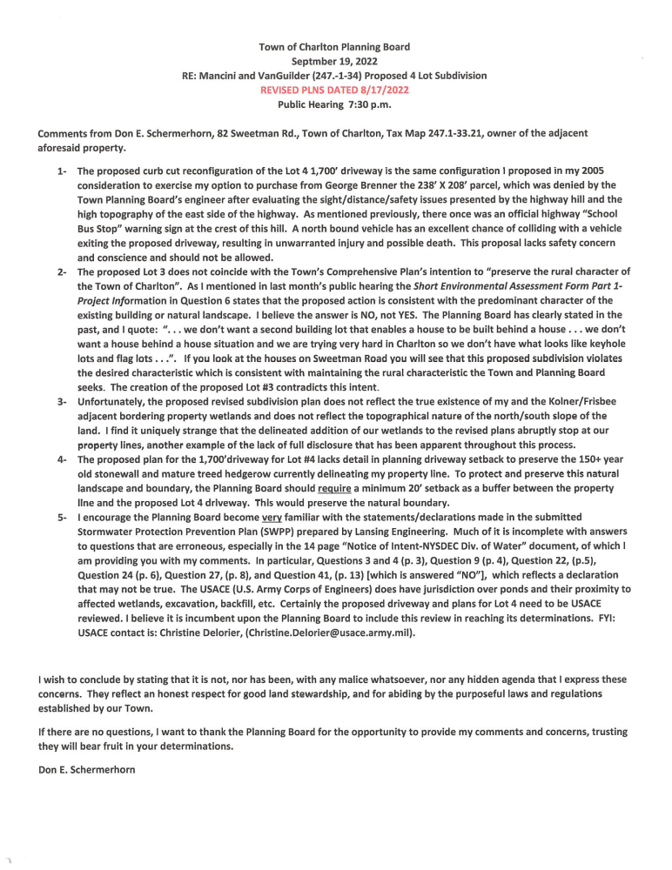
Connie Wood: Is any of the land, your land and the neighbors, has it been drained with tiles and such? Do you have drainage tiles that are leading into this?

Don Schermerhorn: I know that my section of the property has not had drainage applied to it. Mr. Kolner’s may have, he can address that question better than I.

Connie Wood: It wasn’t done years and years before you were there?

Don Schermerhorn: I am not aware of any previous but it could be. There was a lot of drainage done over the years.

Dawn Szurek: When you were discussing the ownership of the trees and the fence lines, usually there is definition in both your deed and their deed so you know exactly who owns the fence line itself and is it right down the middle or is it really belonging to one or the other.

Don Schermerhorn: I haven’t seen that.

Dawn Szurek: Your deed would probably address it as well in your own deed.

Don Schermerhorn: I haven’t seen that in my deed, I will double check.

Bryant Kolner, 80 Sweetman Road: First before I read my comments, the website, which I would expect to be updated all the time, does not have this layout with the new driveways. It has the driveway going down in front over the crest of the hill. I looked at it again today. So your website is not accurately depicting for us where the driveway is. Also, your board site visit, do you have a report? Is that going to be made available on the website so that we can read it?

Jay Wilkinson: Yes.

Bryant Kolner: Well its not there right now.

Jay Wilkinson: We have two weeks to put it up and we will get it up there.

Mr. Kolner read the following into the record.

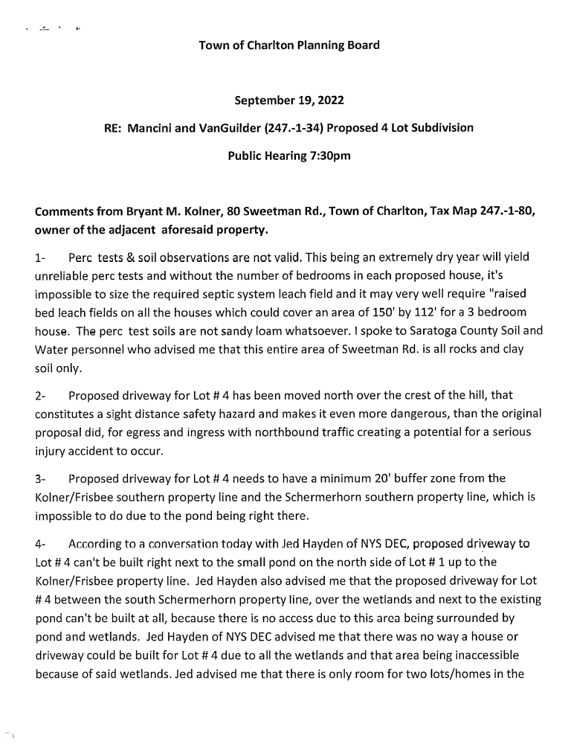
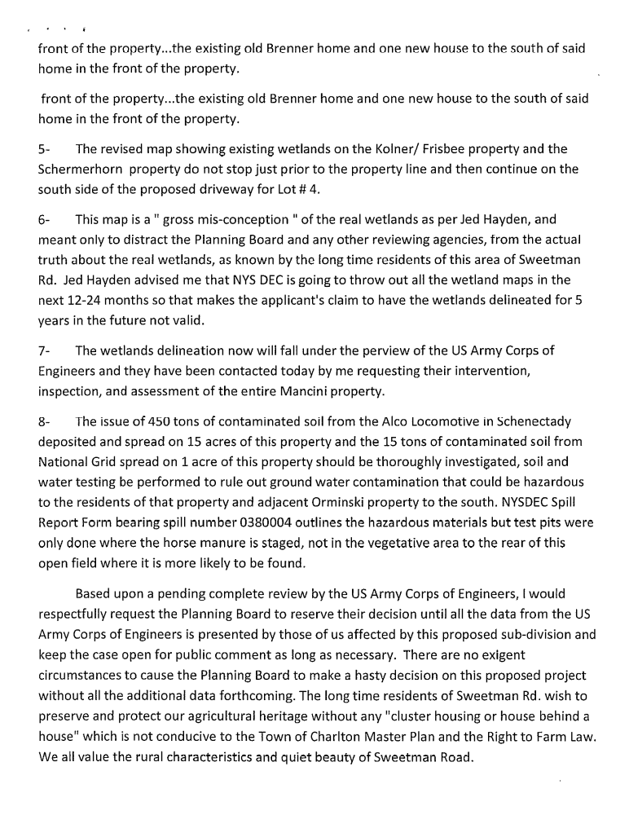


Connie Wood: You alluded to the fact that you have had your land drained. You have had tile put in?

Bryant Kolner: Saratoga County Soil and Water came up and mapped out that entire corn field which is the whole length of the property line between us and Mancini’s. Myself and Al LaRue put in 3100 feet of drain tile in there that I paid for out of my pocket and AL helped me put it in. All that drains down to Sweetman Road at the bottom of that hill you will see that there is a culvert with a cross into a wetland stream on the LaRue property.

Chris Mitchell: So it all drains to the north.

Bryant Kolner: It drains northwest. Actually due west. You can clearly see that there is a cut out right there and there is a stake right there in the road at the bottom of the hill and you can see the exit point onto the wetlands.

Dave Orminski, 50 Sweetman Road: This is a printout of what I said last month.

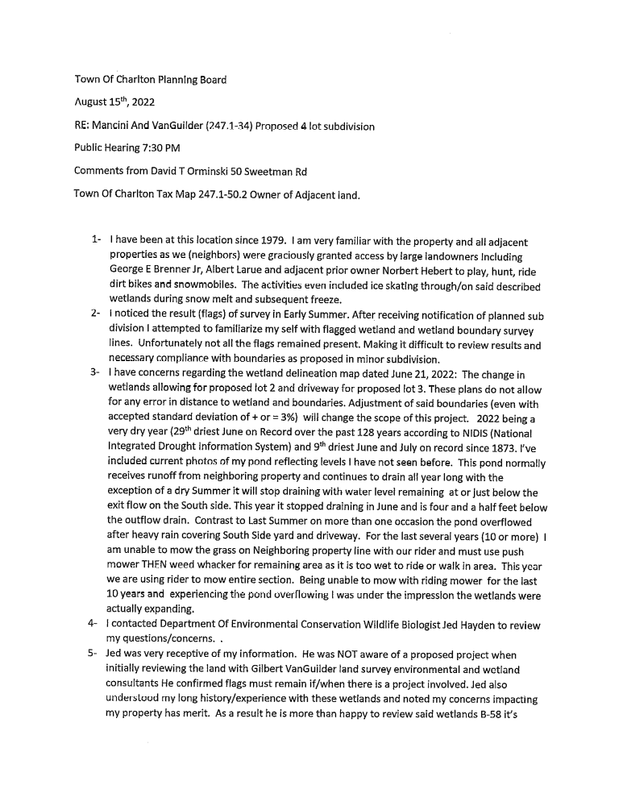
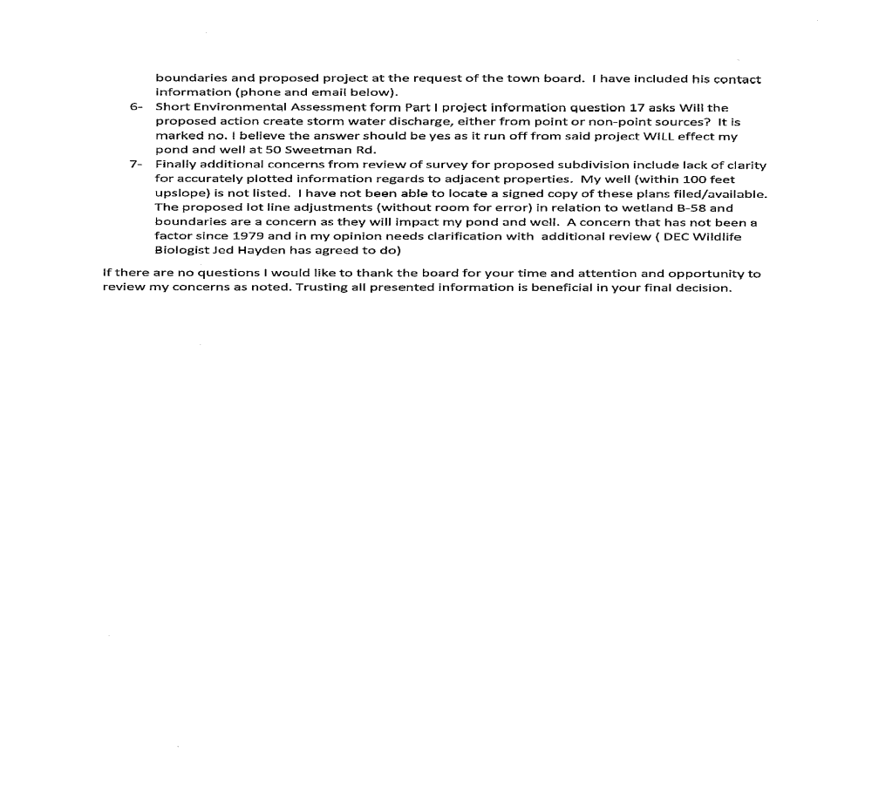

Dave Orminski also read the following into the record.

Dawn Szurek: Which pond overflowed?

Dave Orminski: Our pond. It is here on this map. The wetlands feed the pond and that was my point last time that the pond is empty. So that was the whole point of looking for some more information on it. (Inaudible).

Connie Wood: Mr. Orminski, how far is your well from this?

Dave Orminski: 47 feet.

Connie Wood: 47 feet from the boundary?

Dave Orminski: From the wire fence. (Inaudible) It is a dug well. Anyone can come and look if they want.

Connie Wood: Is the well cased?

Dave Orminski: No, it is a dug well.

Connie Wood: It’s a hand dug and it’s not cased?

Dave Orminski: It is not. It’s concrete.

Dave Orminski showed the location of the map.

Dan Stedman, 110 Sweetman Road: Fortunately I am not in the predicament that some of these other people have already presented. I am down on the corner (inaudible). We are celebrating 33 years there. Maybe some of you remember when we first moved there in our travel trailer for the first few months. (inaudible). It certainly did not look like it does now. Why am I saying this? Because in that 4 or 5 year period we put in almost $200,000.00 and that was 30 years ago mind you. When I look at this place up here, we lived in other places in the area and in the capital region, Scotia, we chose Charlton because we like this look and the fact that it was country area. From what we understood from people was that it was meant to be this way and this is the way the Town of Charlton wanted it. Now maybe it’s just a piece of language but I certainly heard the word “subdivision”. That means a lot today. Previously it was “well these are just lots we are planning so that our children can have a place to build a house”. Admirable. Mine are in their 40’s. I can tell you that what they feel like at 2 or 3 does not usually pertain to what they feel like when they are 25. So my point is and again I don’t mean to be mean to anybody here or anything else. I have an investment. There are a lot of people that have an investment. They chose Charlton because they want it to stay rural. When you start talking “subdivision” we are going around a lot of areas that look like wetlands to me and maybe they didn’t 2 months ago because this is one of the driest years I have seen in my 33 years here in Charlton. Mr. Orminski’s pond, you know, I have seen that overflow the bank and I don’t think there is 5 gallons of water in there now. My feelings and what I want to say to you folks is let’s keep this Charlton like Charlton. Because when you start doing this and there is another 60 acres involved in there that belongs to one subdivision it can suddenly have plans (inaudible). I don’t think we want that. I know I don’t. We are coming to the end of our road in Charlton type of thing, I understand that, but I have seen Clifton Park, I have seen Ballston Spa, I have seen all these places (inaudible). I don’t want to see that in Charlton.

Peter Murphy, 116 Sweetman Road: This really isn’t, my statement is not concerning this specific property. I have a very close friend who is a real estate developer. I already gave him a copy of this. He has also given it to his lawyer. He now thinks that the town of Charlton is open to real estate development and I would say this planning board, this guy is a multi-millionaire. This planning board is going to come back with some more things. He is going to buy land for real estate development and subdivisions and he already has a copy of my plot.

Jay Wilkinson: I think what we should do in light of all the information that was presented tonight, its new, we have some questions that have been raised by Mr. Schermerhorn and Mr. Kolner that need to be addressed. I say we should leave the public hearing open another month till our next meeting to give us time to look at all of this information that has been presented tonight before we move forward.

Connie Wood: Has an appointment been made to have ACOE personnel come and look at this property? Is that my understanding or am I misunderstanding something?

Dawn Szurek: Somebody mentioned Jed Hayden.

Connie Wood: Are you planning on having personnel from ACOE come out and take a look?

Bryant Kolner: The request has been made and I am just waiting for a reply. (inaudible).

Jay Wilkinson: I think we need that information before we can go forward. We will leave the public hearing open and we will revisit this next month.

Jim Glavin, 35 Vines Road: Thanks to the planning board. Do I have 5 minutes? Is that the amount of time? I won’t take it Probably only half.

Jay Wilkinson: Ok. We don’t put a time limit. We let people speak as long as they need to.

Jim Glavin walked over to the applicants to introduce himself and shake hands.

Jim Glavin: So I just want to state for the record as a resident in the Town of Charlton I am a strong believer in processes. The planning board has a very very good process and its really backed on and based on town ordinances, laws and codes. I stopped by tonight because I just wanted to be part, wanted to hear what was going on in this public hearing. I know that there has been a lot of opinions thrown out and I am sure some of them are based in fact. I just want to go on record stating that the Mancini’s have every right to be here. I am a strong advocate of all property owners’ rights. So not just the Mancini’s but everybody else here. I did want to make it known that I support what the Mancini’s are doing in terms of going through the process and doing something on behalf of their family. You know, they are property owners here in the town of Charlton and I just wanted for it to be on record that I support what they are doing in terms of process. I wish you the best going forward. Does anybody from this side have any questions?

Dan Stedman: You live on Vines Road?

Jim Glavin: Vines Road, correct.

Dan Stedman: And the drainage or any of that stuff affect your property?

Jim Glavin: I am not sure about the drainage but I doubt it will affect mine. I am pretty far from it.

Dan Stedman: (Inaudible)

Jim Glavin: I am sure the adjacent property owners, from a concern standpoint, but I would just suggest that if we follow the process and we do due diligence on all of the engineering as part of this things like the drainage, the runoff, septic, anything that is on record in terms of the property from environmental, should all come to light.

Jay Wilkinson: Our attorney, Bill Keniry, has always preached that from day one. If you just follow the process and go through it you will come to the right result. I am personally very proud of this board and being the chairman for the last 15 years. Connie Wood has dedicated 30 years to it; Dawn Szurek came shortly after I did. We have all been just following the process and that’s what gets us through these. These are very difficult. It is not easy to sit up here and try to come up with the right answer and Mr. Keniry says that to me all the time when I sometimes get frustrated and I ask him what to do he says ”just follow the process, it will lead you to the answer”. That’s what we are going to do and that’s why we are saying that we are going to keep it open tonight. I know the applicants want due process, they want to get some answer/result but we don’t have all the questions answered yet and I don’t think this board wants to give an answer that is incorrect or afterwards we say we wish we had that other piece of information. It could be for or against but we need to follow the process. So we will see if we can get ACOE out there and give us some more information and then we can get to the point where we can deliberate on it. That may be next month, that may be November. It’s just following the process. Thank you for your thoughts.

Kevin Weed: So I just wanted to touch quickly on the questions on the ACOE jurisdictional wetlands. We have had them on the map listed since day 1. All of the wetlands are ACOE jurisdiction including the ponds, that has never been a question. DEC only took jurisdiction of this here, all the rest are labeled ACOE. DEC did review the delineation of the entire property. They did agree to it with no changes. They only took jurisdiction of this piece here. I also have here tonight the National Wetlands Inventory Mapping if the board would like to see it, which is the federal pubic wetland map. And actually for this property, they show less wetlands than we delineated. They did not have these wetlands up here in the front. We did delineate all of the wetlands on the property, DEC did review it. After the last meeting, we got a second letter from DEC where they acknowledge that they did review the subdivision map and that there were no concerns and it would not require a permit. Also I think it’s worth pointing out, every house, and every septic area and well that we have proposed is at least 100 feet away from all wetlands on the property regardless of their jurisdiction. The only places where we come even close to a wetland is on Lot 4 which, again, is an existing driveway. It’s already there. The culvert is already there. It has been there since at least 1952 according to historic aerial photos. That is the only place where we are even close to the wetlands and because it is already there, there is no proposed impact. There is no proposed impact for this entire subdivision anywhere.

Jay Wilkinson: That is good to make it clear so we are all on the same page.

Dawn Szurek: I heard a couple themes coming from the people that spoke. There were some concerns about the proximity of the driveway on Lot 4 to the stone wall and what is going to happen with the trees and as I look at the drawing, obviously that would be a question because it doesn’t say how many feet. When you look at the drawing it looks like the driveway is right on that stone wall. But then when you walk the property it appeared that there was a different amount of distance there. It looks larger than what looks to be here. Is there a way for you to clarify that and perhaps address the concern of the person that spoke about that tree line, the fence line and the proximity of that driveway because there is no definition of distances here or how wide that driveway is. I mean it’s just a visual and when you look at the visual it really does look like all those trees will be mowed down and the driveway is going to sit on the wall. Again, when you walk there it looks different. Can you address that and that may help the public concern that was brought up.

Kevin Weed: Absolutely.

Dawn Szurek: And there could be some definition between the deeds anyway of who owns what because sometimes they define who owns the stonewall. The other, there was a lot of discussion about the runoff and it impacting wells and everything to the south. As you look at the drawing, I am guessing they are bringing it up because you could probably further subdivide Lot 3 and you could further subdivide Lot 4. To maintain rural character in the town of Charlton, I brought this up in the last meeting, and if you would ask the owners, if they would consider stating no further development on parcels 3 and 4 because that may help address the other public concern about impacting wells to the south and creating further runoff situations if there is further development.

Kevin Weed: Regarding the driveway for Lot 4, I think because this is 100 scale map because it is such a large piece of property, I think that is playing a little bit on the visual impact here. Again, this driveway is already there. It is already not affecting the stone wall or the fence. There is a few feet of separation, probably 4-5 feet from the stone wall to the existing driveway as it is now and that is going to stay that way. There is no intention of clear cutting trees or anything like that. There will have to be some branches cut down yes, that are hanging so that fire trucks can get in there if necessary. What we are showing here is a 16 foot wide driveway. That does not mean that the driveway is going to be actually 16 feet wide on the surface. (inaudible) two foot slopes that go back down to the existing driveway. The entire 16 foot footprint will be able to fit on the driveway that is there now with two proposed turnouts on the south side of the driveway. So again, we do not impact the stonewall or the fence that is there now. Also, (inaudible). Some members of the planning board did walk the entire length of that driveway. It is there and it is not going to have trees cut along the fence line or the stonewall. As far as the deeds, there was no indication of the stonewall mentioned. (Inaudible). Regarding further subdivision of the lots, Lot 3 does meet the existing requirement of 200 feet of frontage but because it has 200 feet of frontage, further subdivision would require a variance.

Dawn Szurek: But there is nothing to stop you from going to ask for the variance. That’s why I am asking the question to preserve rural character would the owners consider saying no further subdivision of Lot 3 and 4. They don’t have to answer now but I asked it once before and I am asking it again as the public is bringing up some issues that they feel. A possible way to help those issues might be to say that there won’t be more development.

Kevin Weed: (inaudible). To put that in the deed restriction will devalue the property. We are dealing with that now on some of the old Van Patten properties in Clifton Park. What it boils down to with the attorneys and lending institutions are focused on what is the written regulation and what are the written restrictions. From a practical standpoint this lot cannot be further subdivided. There is no way they would be able to get the permits to do it. There is no intention to further subdivide. Putting a written restriction on it will affect the value of the lot if they were ever to try to get a mortgage against the parcel to get a loan using the parcel as collateral that would negatively affect that. That is one of the reasons why they have not been willing to take that extra step in putting it in there. (Inaudible).

Dawn Szurek: I am not going to argue but that sounds contradictory because the value would be defined by what is possible. So is the bank being deceived? I am leaving it there. I am not going to argue the point.

Chris Mancini (from the audience): (Inaudible).

Don Schermerhorn (from the audience): (Inaudible).

Jay Wilkinson: We are still asking it. We can’t force anyone to put that into the deed. Is that correct Mr. Keniry?

Bill Keniry: Yes.

Jay Wilkinson: That is something we ask and you were willing to do it. That helps. I wasn’t on the board 16-17 years ago.

Bill Keniry: (Inaudible).

Don Schermerhorn: Let’s just say that was a requirement to get the approval.

Chris Mitchell: I have never known it to be a requirement for approval. It is usually at the volition of the property owners.

Jay Wilkinson: We can’t enforce that and make anybody do that.

Don Schermerhorn: (Inaudible).

Bryant Kolner (from the audience): (Inaudible). No question it has been there since the 60’s, but that lane is a tractor lane (inaudible) It has never been a road or a driveway it is a tractor lane. (inaudible). False representation of what that is. It is merely a tractor lane to the woods (inaudible).

Many of the audience members began speaking at once.

Paul Hibbert, 44 Sweetman Road: (inaudible). Always wet.

Jay Wilkinson: I think in light of all the information, like I said before, we will keep the public hearing open until the October meeting. Mr. Weed, can you follow up with ACOE to get the information. Mr. Kolner said he made contact and is waiting for someone to get back to him. I am sure you have people that you talk to all the time and deal with. Is there some way we can get some information from them or you could get them to address some of tonight’s questions and resolve the jurisdiction and how/where the wet is, something to help us move forward.

Kevin Weed: We can definitely reach out to them. I will say that in recent experience in dealing with ACOE, it could take a year to get them to actually come out there due to short staff. We can definitely try.

Chris Mancini (from the audience): (Inaudible).

Jay Wilkinson: We are asking your representative to contact ACOE and to get us additional information that has been brought to light to us tonight about this piece of property. Mr. Weed you were just saying that the majority of this property is ACOE and you had pointed that out that there is only those two areas that are DEC.

Kevin Weed: All of the wetlands we have delineated are ACOE jurisdiction. Those wetlands mirror the (inaudible).

Jay Wilkinson: I am confused. You said you had Jed Hayden out and he is DEC not ACOE. I thought you pointed to those two things that look like streams that come down and go down towards Orminski’s pond. What was that about?

Kevin Weed: So Jed Hayden from DEC has been out on the site and reviewed the wetland delineations of the entire property and has agreed to it. (inaudible). At the end of the day, he only took jurisdiction of this portion but he reviewed all of them. The national wetlands inventory, which is a federal level mapping publicly available mapping, has the wetland corridor here which we have delineated, here but they did not have this wetland and this wetland which we have delineated which Jed said yes they do exist they are there and then we have ACOE. What I am trying to point out is that the ACOE map that is publically available, we have all of their wetlands accounted for and then some.

Jay Wilkinson: Jed Hayden can speak for ACOE?

Kevin Weed: That is the normal process that we go through because DEC, because of the 100 foot buffer, we need to be more aware of that because (inaudible). ACOE you can build right up to the edge. That is the normal process we go through. DEC is more responsive. We can usually get DEC to come out in a week or two, ACOE is a lot harder.

Mr. Wilkinson made a motion for the board to enter Executive Session. Mr. Mitchell seconded the motion. All were in favor.

The Board entered into Executive Session at 8:43 p.m.

The Board returned from Executive Session at 8:55 p.m.
Jay Wilkinson: There were no votes taken, all we did was ask for procedural information from our counsel on how to proceed. With that all said, we are back at 8:55 p.m. I made it clear, we are keeping the public hearing open until our next meeting, our October meeting. It will be at 7:35 p.m. the reason for that is that there has been a bunch of questions that have been raised tonight that the board needs to consider and deliberate to absorb that information that was given tonight and think about it so that when we come back next month we can deliberate on it. Also I would ask that Mr. Weed make an effort to try to get a hold of someone at ACOE and report back to us next month about what you found.

SUBDIVISION APPLICATIONS

Mancini and Van Guilder (247.-1-34)

There no deliberations on this application.

ZONING REPORT

The Board reviewed the report.

CORRESPONDENCE

None.

TOWN BOARD LIAISON

Mr. St. John stated that bulk item pick up is October 24-29. Mr. St. John said that the fall newsletter will be out soon and has more information. Mr. St. John stated that the Ballston Library has submitted their budget presentation.

Mr. Wilkinson made a motion to adjourn the meeting. Mrs. Wood seconded the motion. All were in favor.

The meeting was adjourned at 9:00 p.m.

Respectfully Submitted,

Kimberly A. Caron
Recording Secretary

